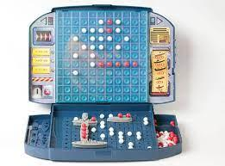 Final Summative – Battleship Tournament 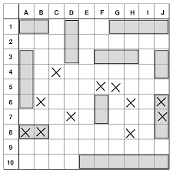

Name: ___________________________

|  |  |
| --- | --- |
| Date | Tasks/Progress |
|  |  |
|  |  |
|  |  |
|  |  |
|  |  |
|  |  |
|  |  |